AWS Lambda,AWS API Gateway & AWS KMS

1.AWS Lambda
2.AWS API Gateway
3.AWS KMS
1.AWS Lambda
- Introduction
- AWS Lambda is a serverless compute service provided by Amazon Web Services (AWS). It allows users to run code without provisioning or managing servers. AWS automatically handles infrastructure management, scaling, and monitoring.
- Lambda executes code only when triggered by an event, making it highly scalable and cost-effective.

- Objective
- To create and execute a simple AWS Lambda function using Python runtime.

- Service Used
- AWS Lambda.

- Use Case
- AWS Lambda is commonly used for:
- Serverless applications.
- API backends.
- File processing.
- Automation tasks.
- Event-driven applications.

- Steps Performed
- Step 1: Open AWS Lambda
- Logged into AWS Management Console.
- Searched for “Lambda” in AWS services.
- Opened AWS Lambda service.
- Step 2: Create Lambda Function
- Clicked on “Create Function”.
- Selected “Author from scratch”.
- Entered function name:demo-lambda
- Selected runtime:Python 3.x
- Step 3: Add Python Code
- Added the following Python code:
- def lambda_handler(event, context):
return {
'statusCode': 200,
'body': 'Hello from AWS Lambda'
}
- Step 4: Deploy Function
- Clicked on “Deploy”.
- Function deployed successfully.
- Step 5: Test Lambda Function
- Created a test event.
- Executed the Lambda function using the “Test” button.

- Execution Output
- The function executed successfully and returned the following output:
- {
"statusCode": 200,
"body": "Hello from AWS Lambda"
}

- Architecture Flow
- User
↓
AWS Lambda
↓
Response Returned

- Advantages of AWS Lambda
- No server management
- Automatic scaling
- Pay only for usage
- Easy integration with AWS services
- High availability

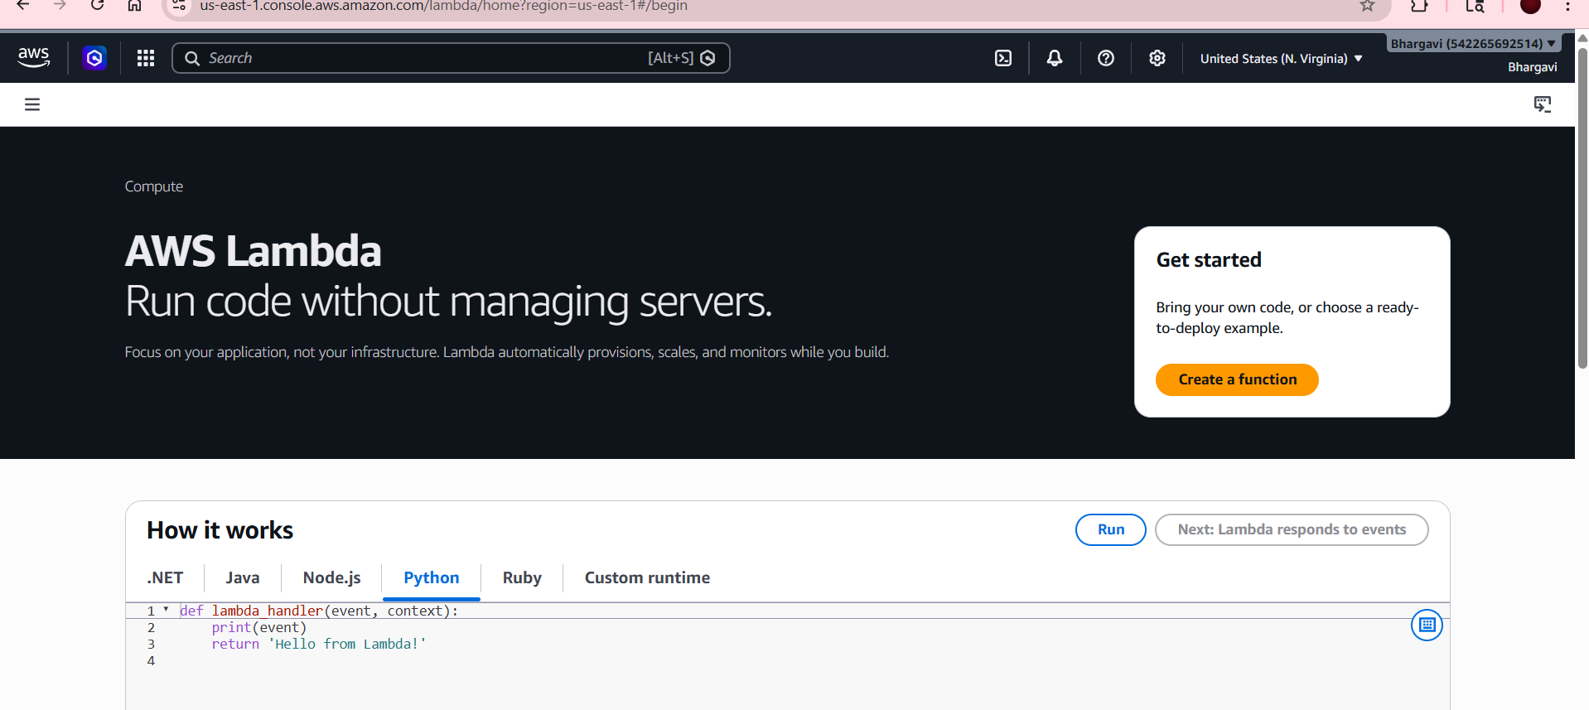
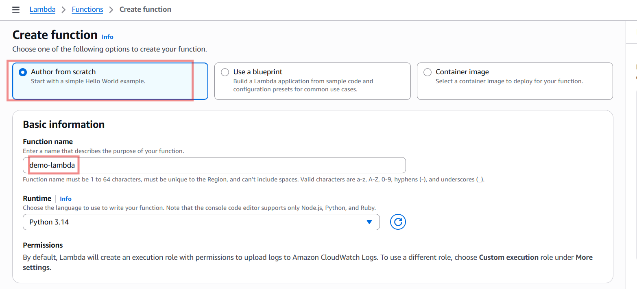
Create function
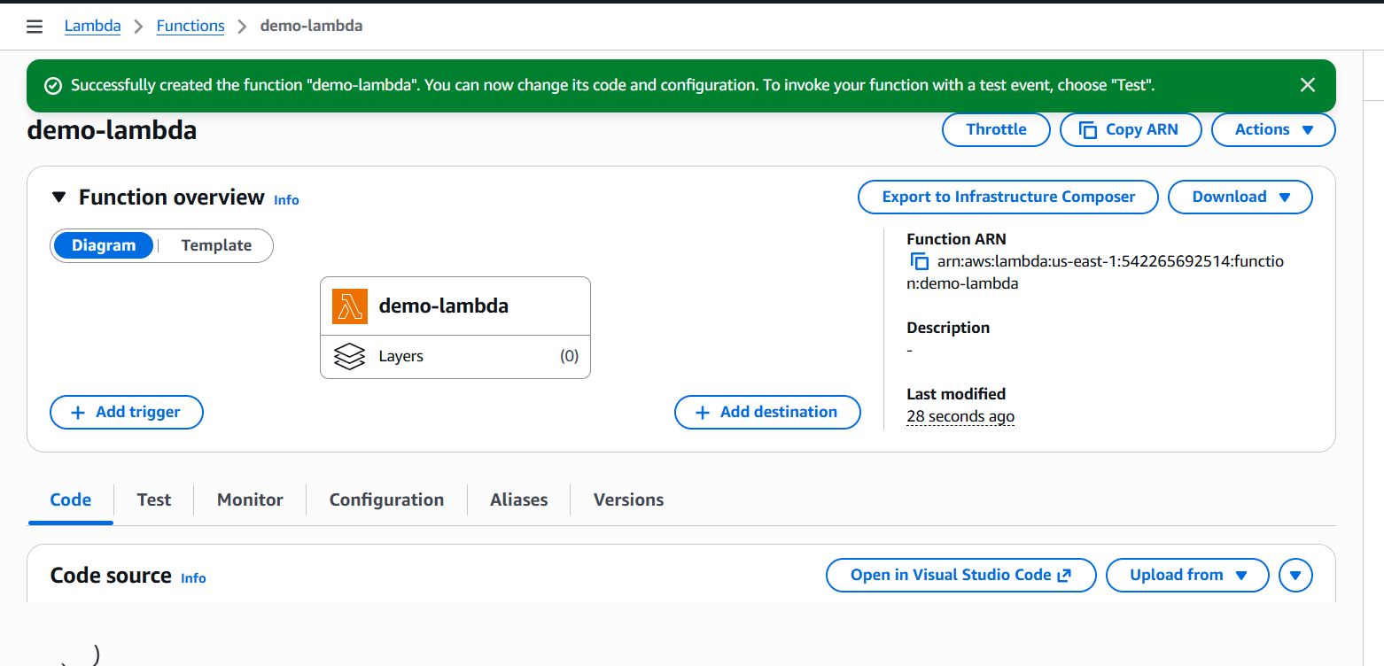
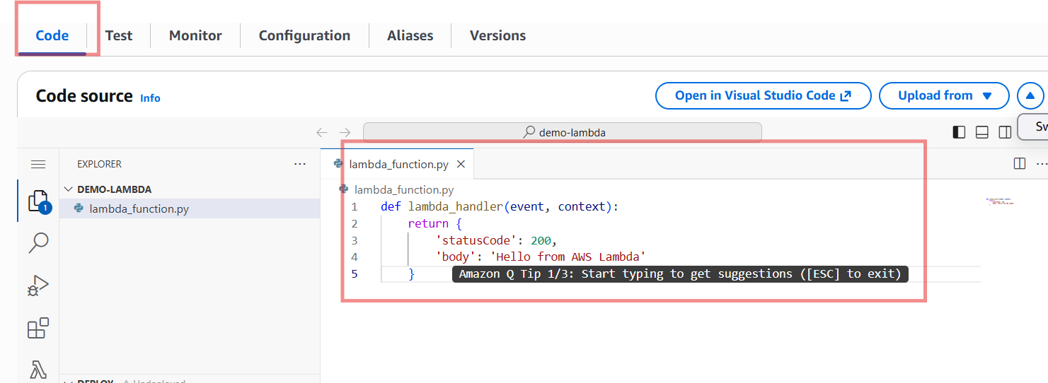
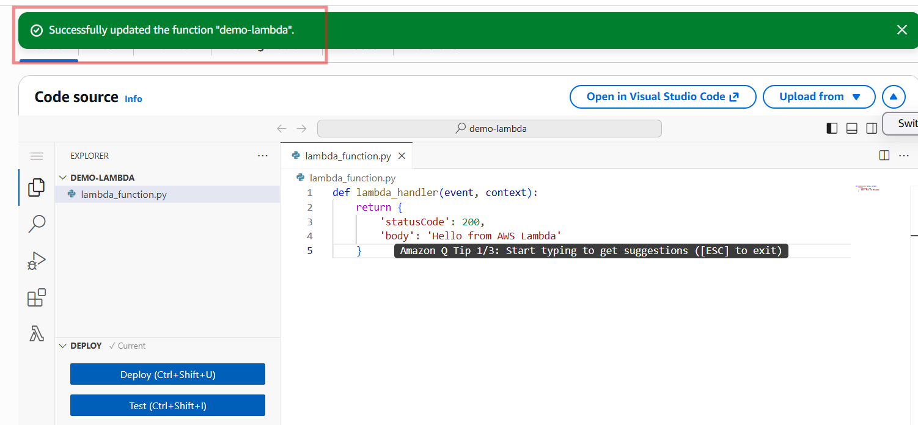
Create Test Event
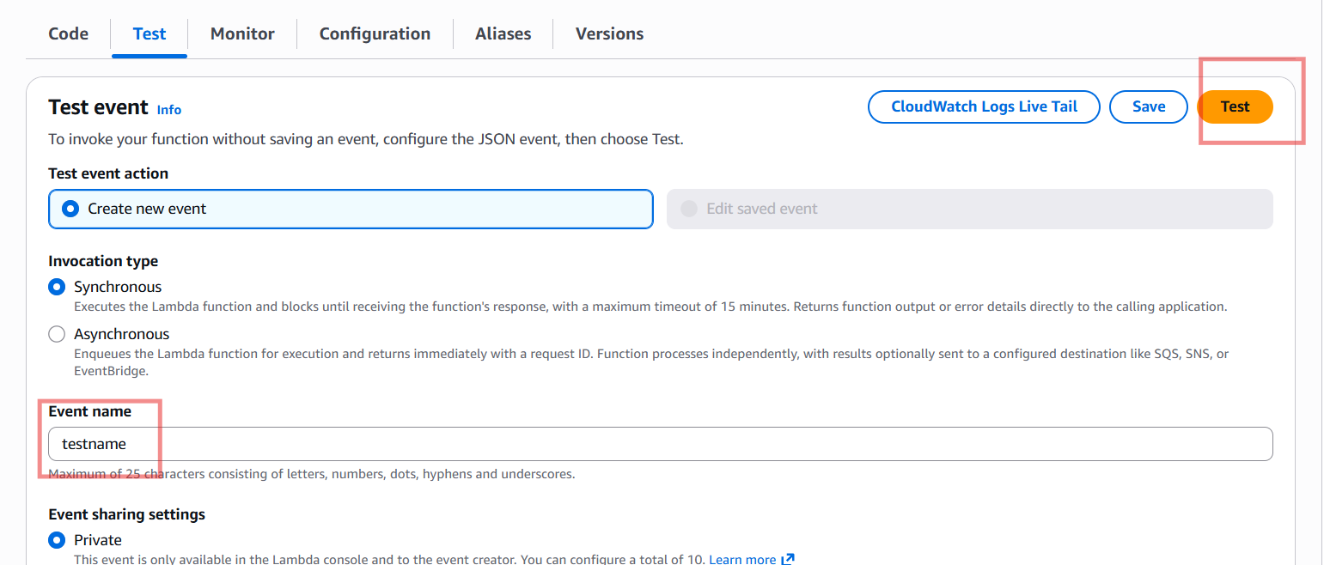
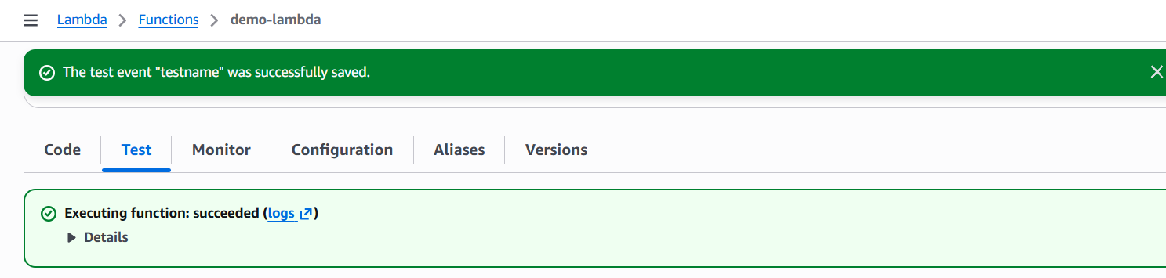

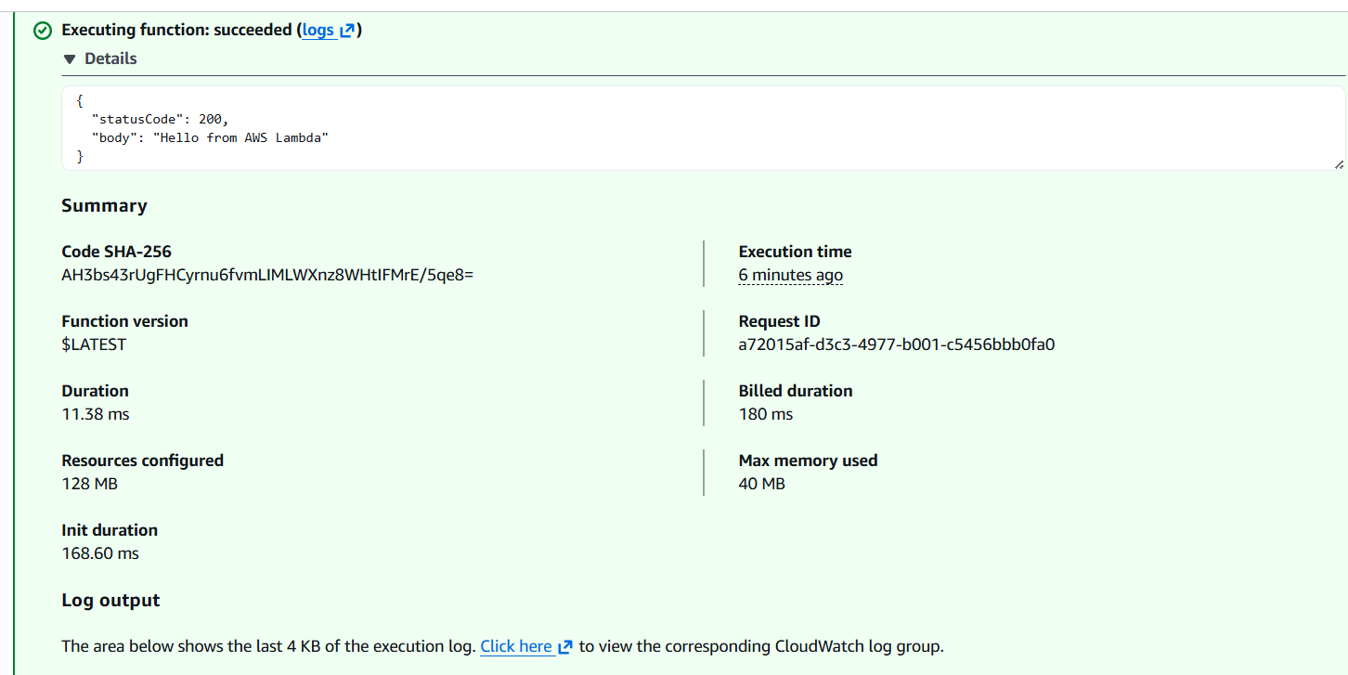
- Result
Successfully created and executed an AWS Lambda function using Python runtime in AWS Cloud.
2.API Gateway
Definition
Amazon Web Services API Gateway is a fully managed AWS service used to create, publish, maintain, monitor, and secure APIs. It acts as an entry point between client applications and backend services such as Lambda, EC2, or databases.
Purpose of API Gateway
API Gateway is used to:
- Receive client requests
- Process API calls
- Forward requests to backend services
- Return responses to users
- Secure and monitor APIs
Types of APIs
1. REST API
- Used for enterprise applications
- Supports API keys and request validation
2. HTTP API
- Low cost and high performance
- Best for simple applications
3. WebSocket API
- Used for real-time communication
- Example: Chat applications
Method | Purpose
GET | Retrieve data
POST | Create data
PUT | Update data
DELETE | Remove data
Advantages
- No server management
- High availability
- Easy monitoring
- Secure communication
- Cost effective
- Scalable architecture
Backend Services Supported
API Gateway integrates with:
- AWS Lambda
- EC2
- ECS
- DynamoDB
- External APIs
Monitoring
Integrated with:
- CloudWatch Logs
- CloudWatch Metrics
- AWS X-Ray
Used to monitor:
- API requests
- Errors
- Latency
- Traffic
  - Architecture Flow
Client → API Gateway → Lambda/Backend → Response
Steps to Create AWS API Gateway
Login to AWS Console Create Lambda Function Open API Gateway Choose API Type Configure API Integrate with Lambda Deploy APICreate stage --Click Deploy API Test API
Conclusion
AWS API Gateway is a secure and scalable service used to create and manage APIs. It helps applications communicate with backend services efficiently and is widely used in serverless and cloud-native architectures.

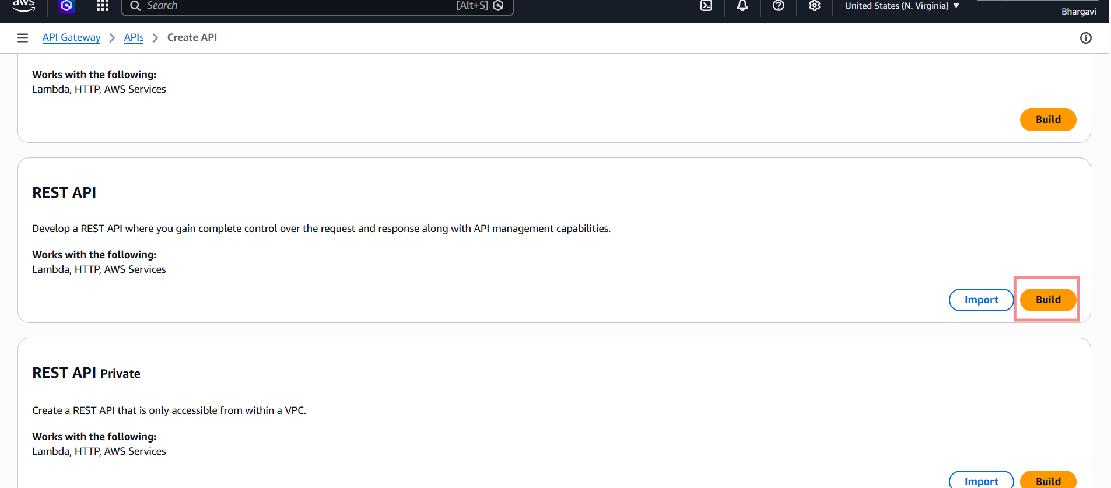
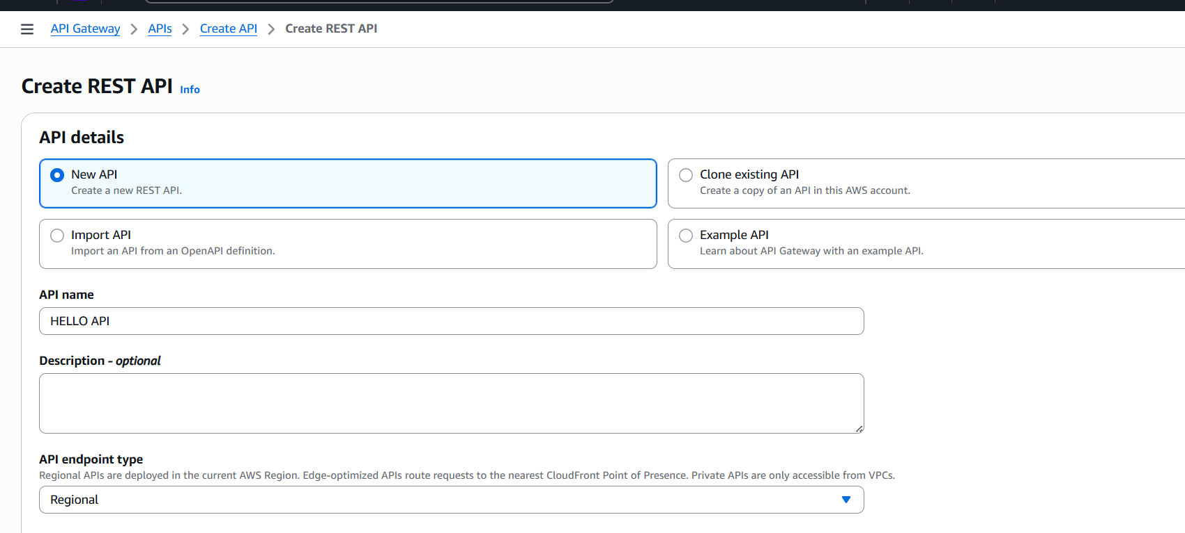
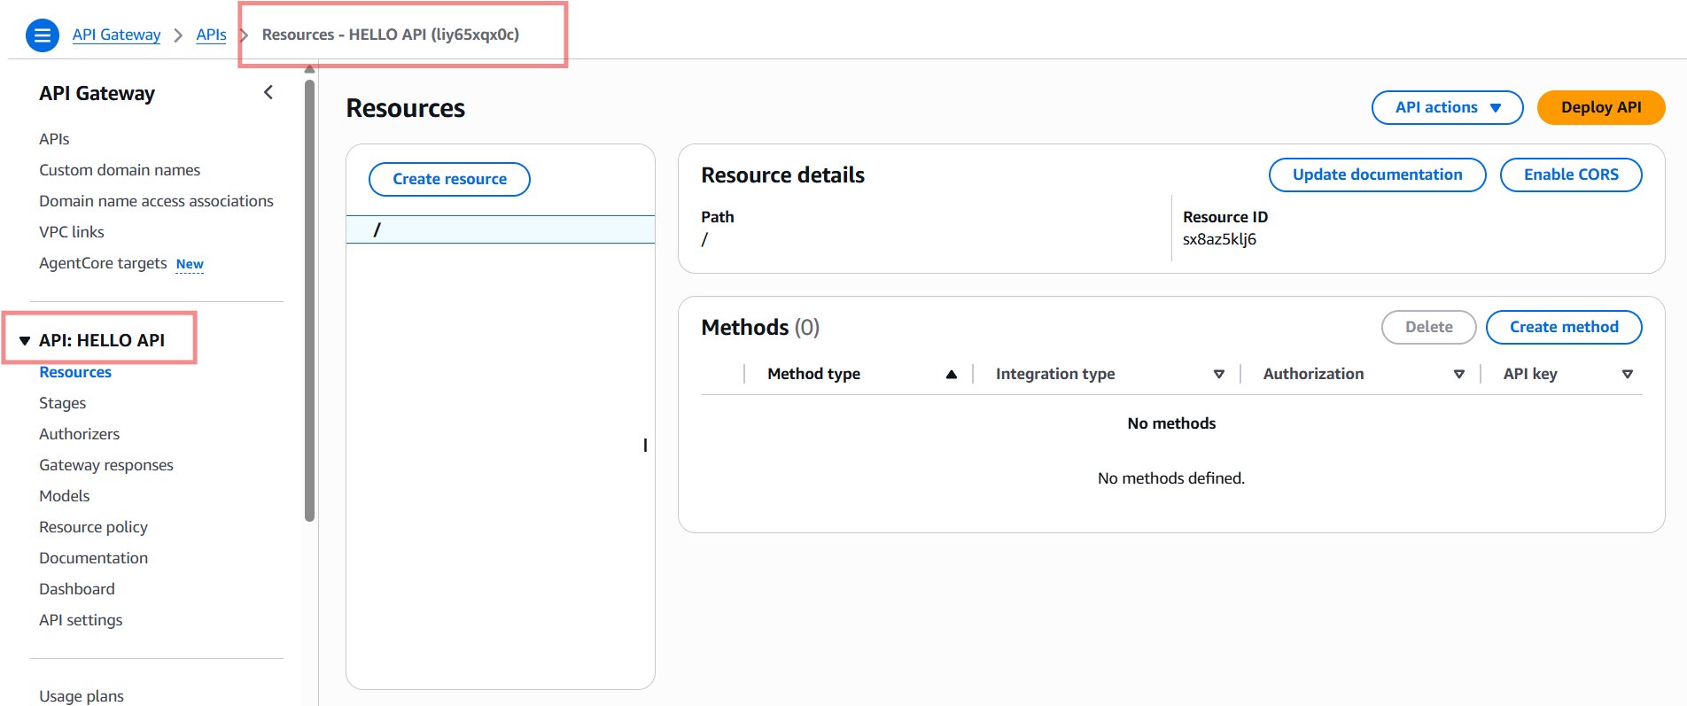
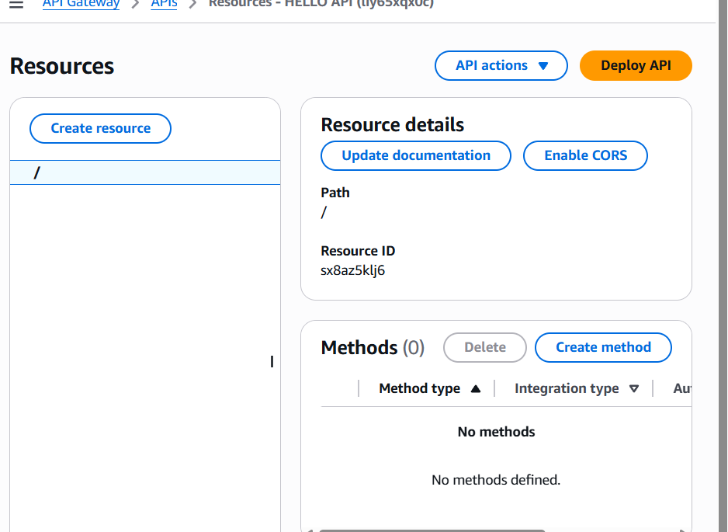
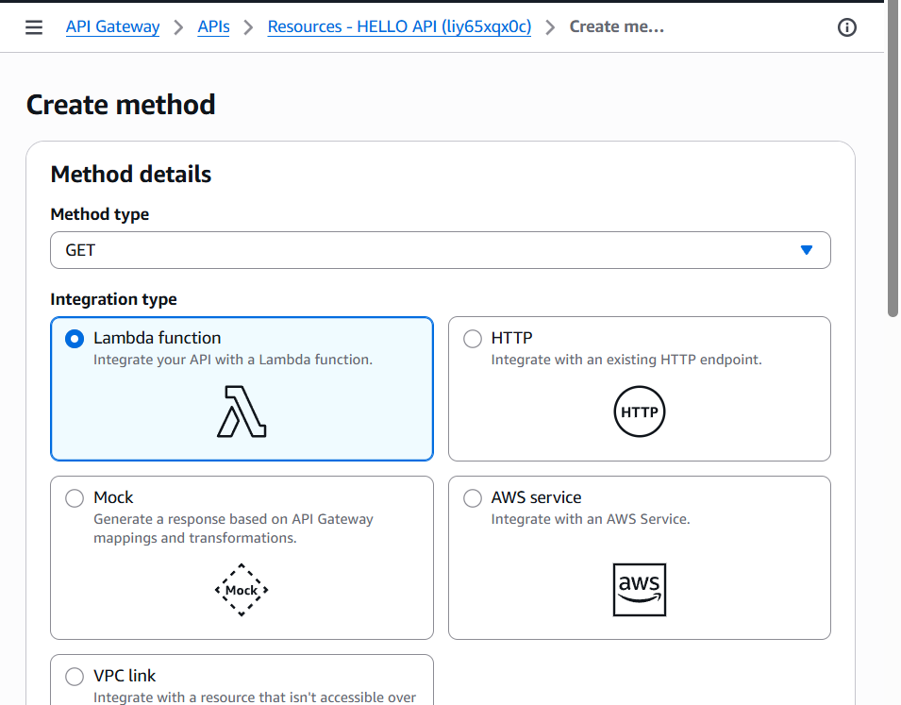
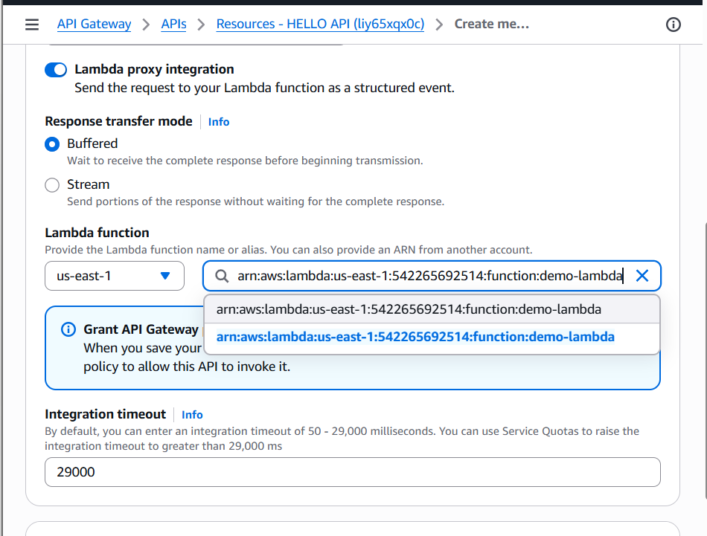
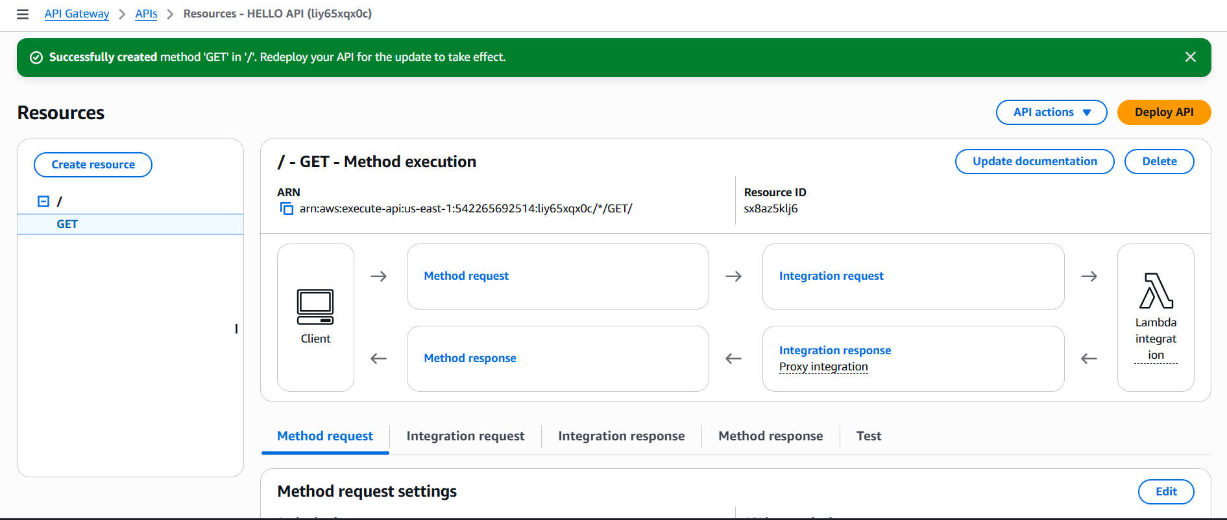
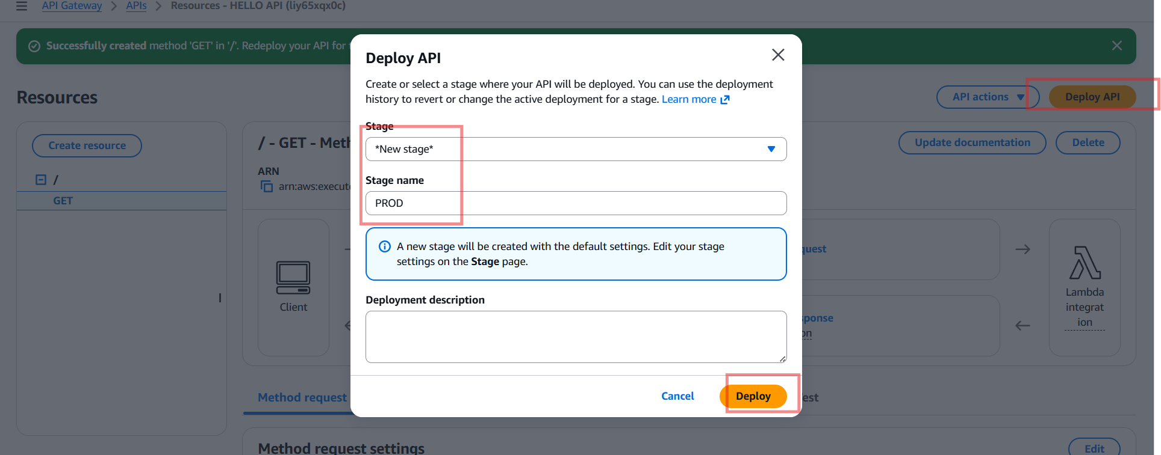
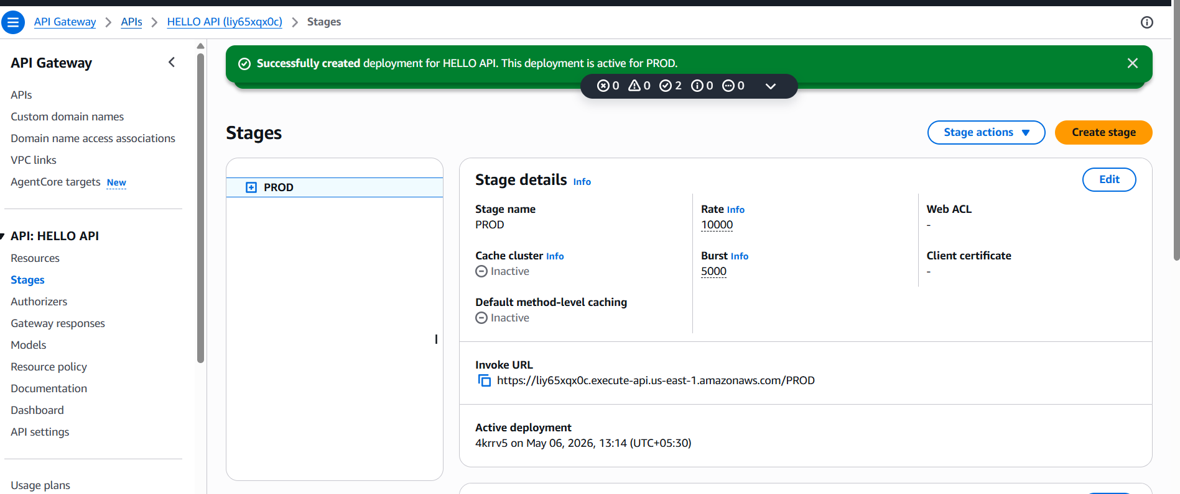
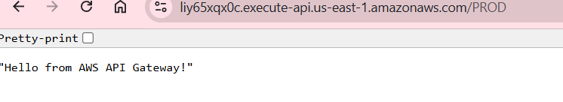
Verify CloudWatch Logs
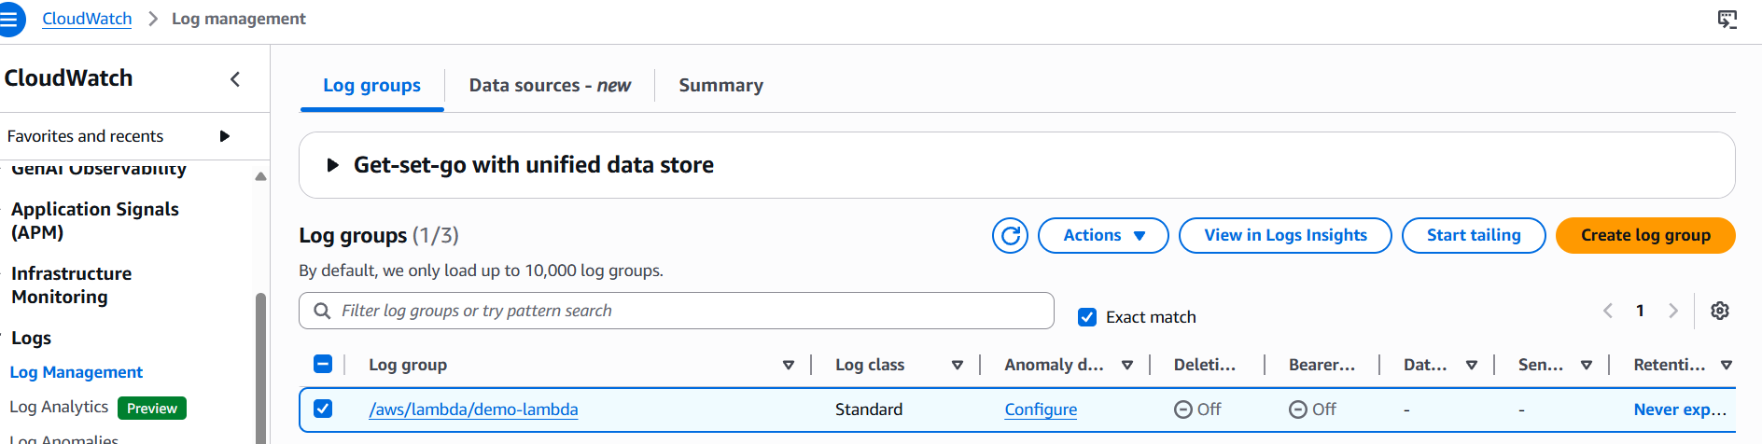
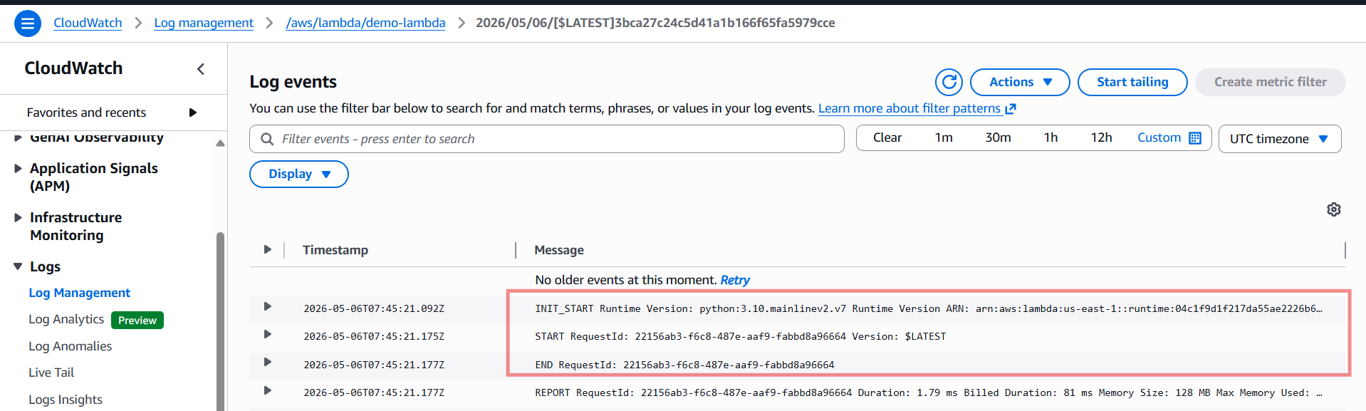
3.Create an AWS KMS Customer Managed Key and use it to Encrypt and Decrypt text data.
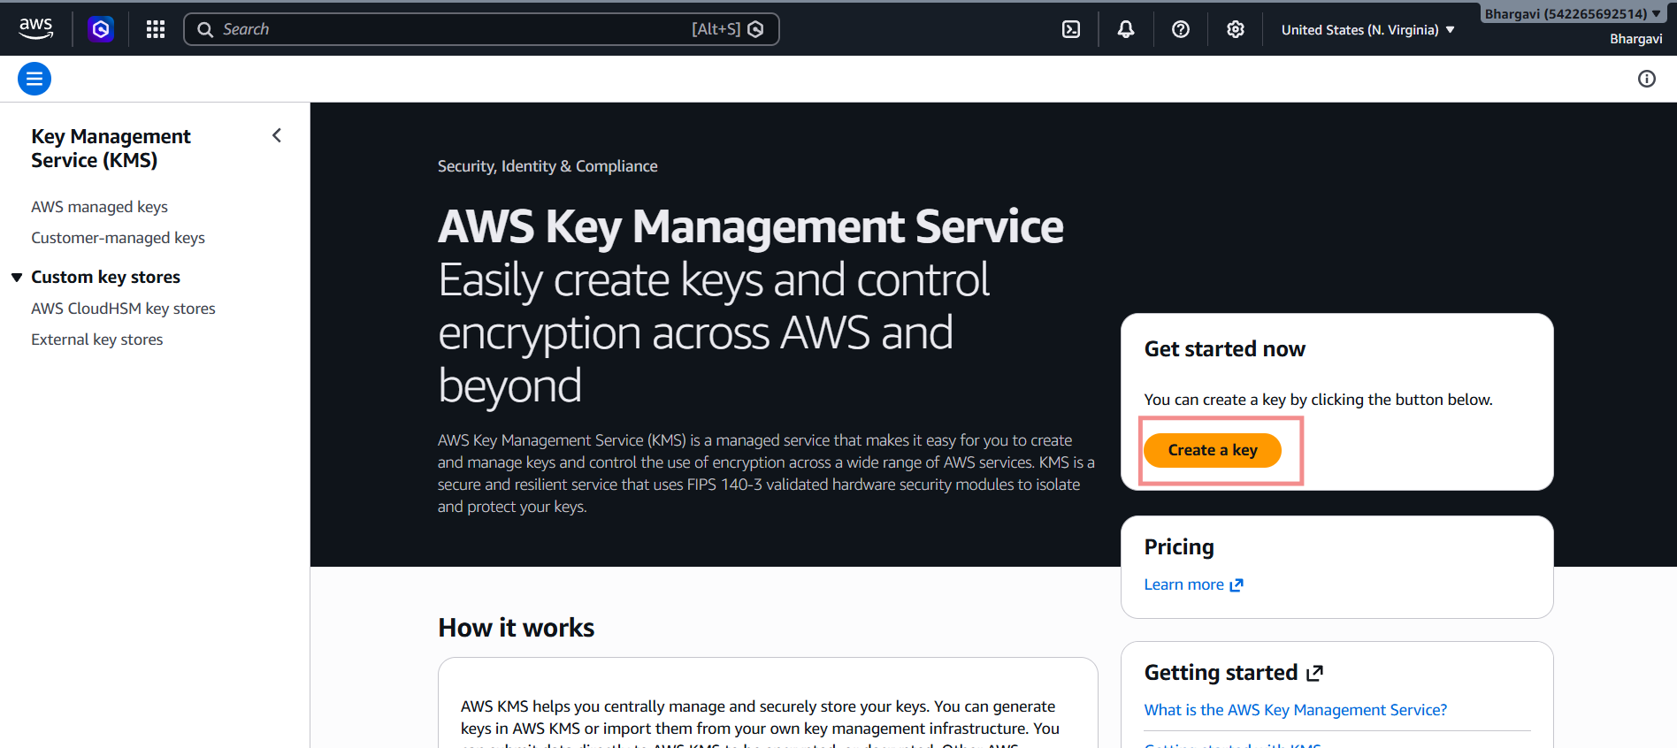
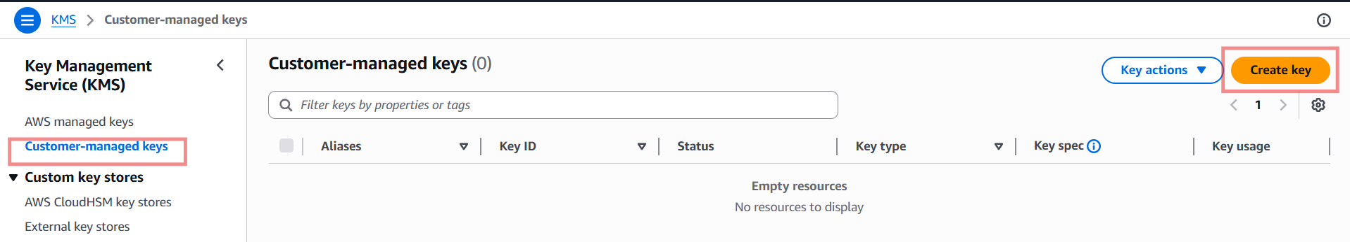
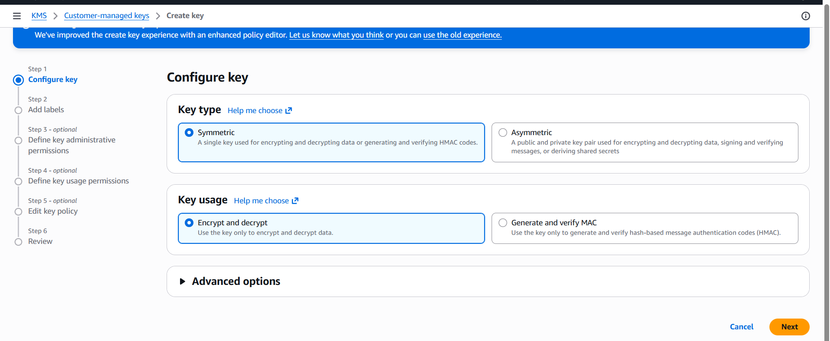
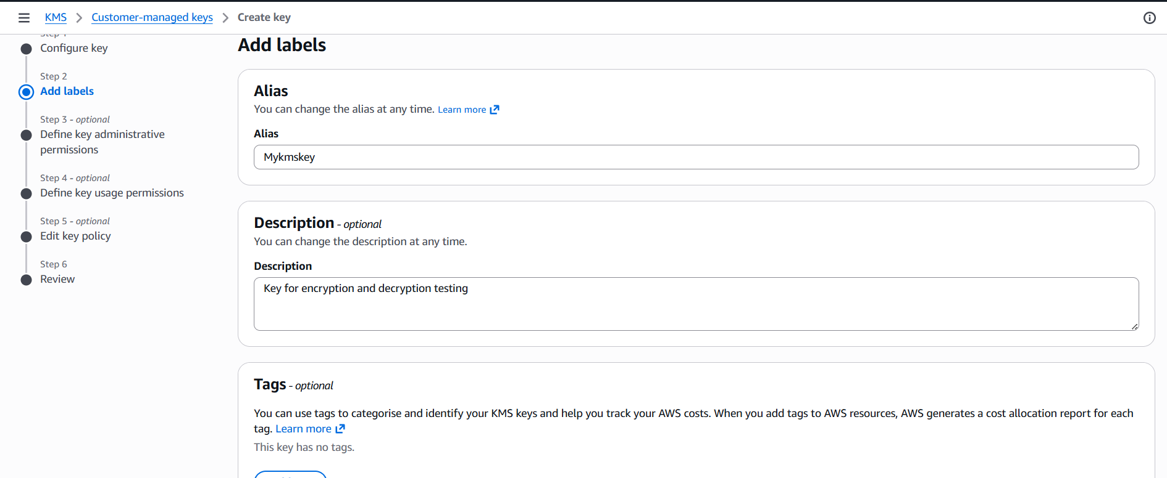
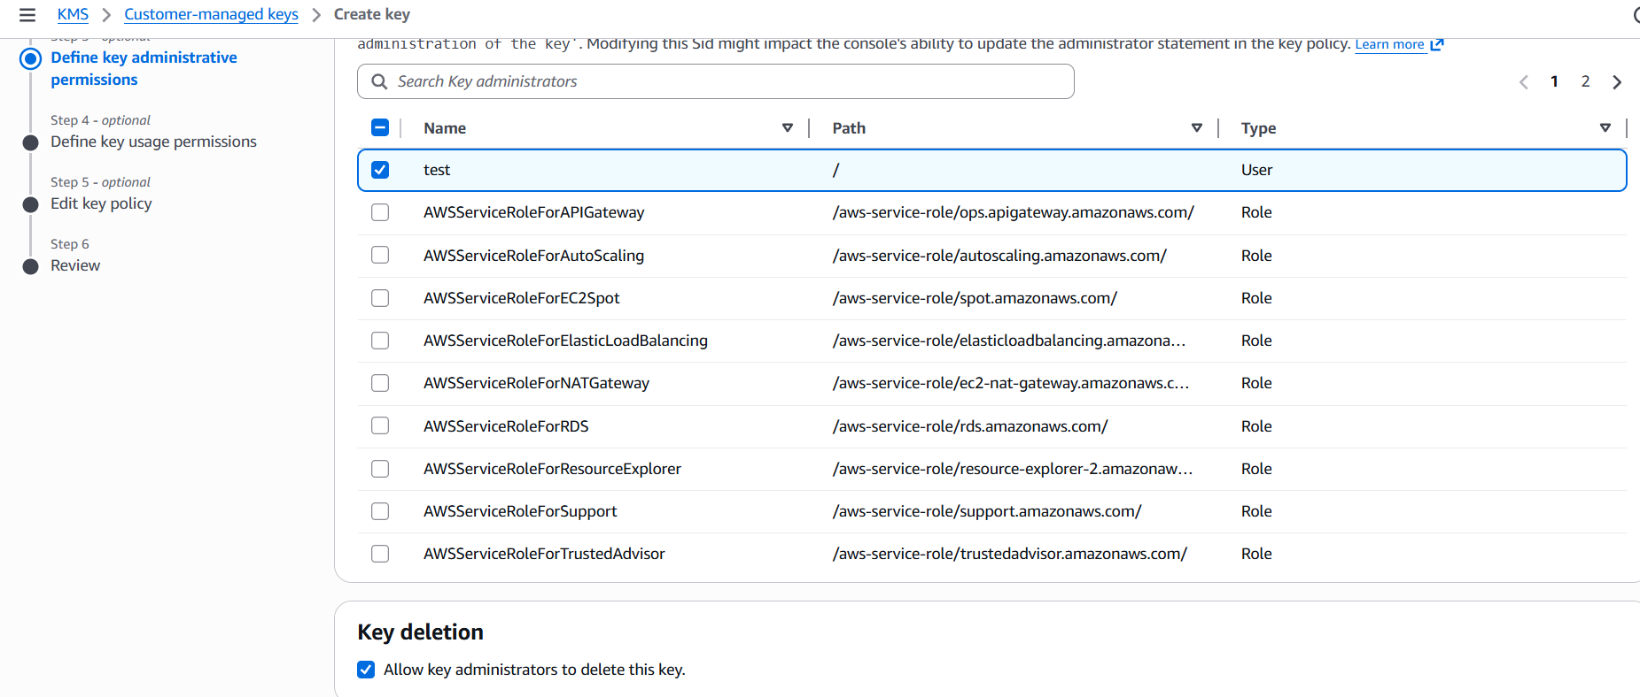
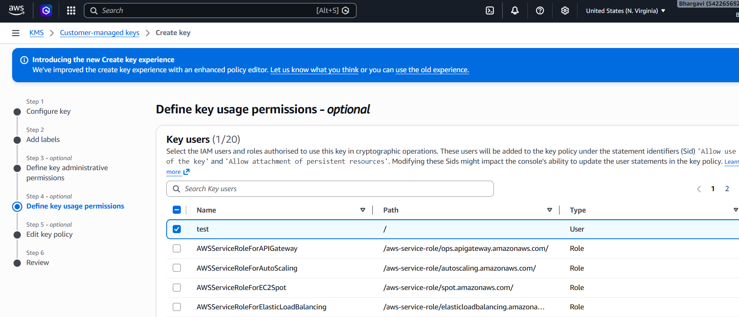
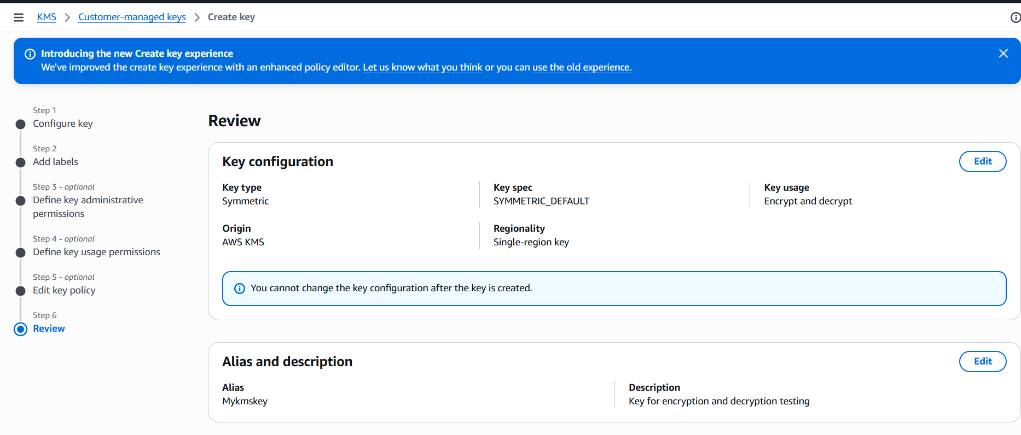
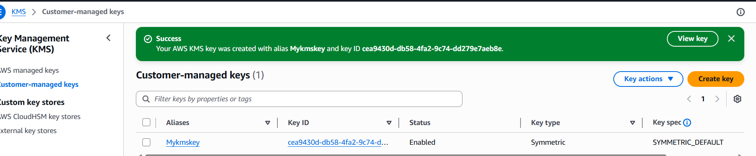
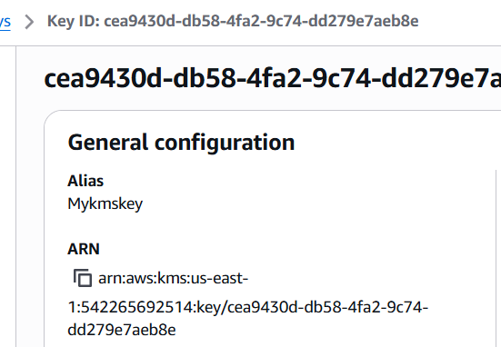
Cloud shell opended
Encrypt Text Using Command
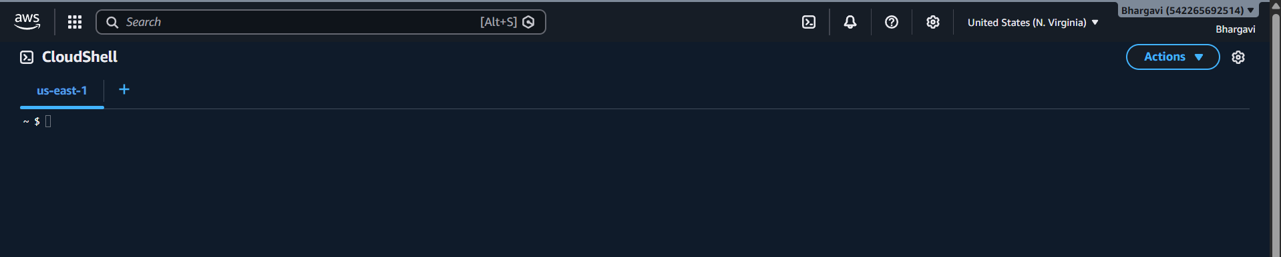

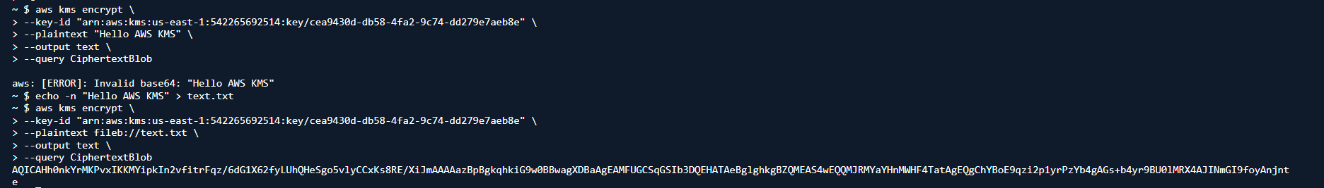
Create Cipher File-- nano cipher.txt-- Paste Encrypted Text-- Save File--
Run Decrypt Command
aws kms decrypt \
--ciphertext-blob fileb://<(base64 -d cipher.txt) \
--output text \
--query Plaintext | base64 -d

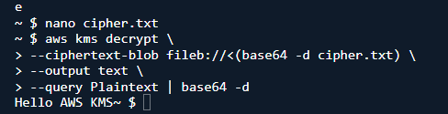

Verify in CloudTrail
